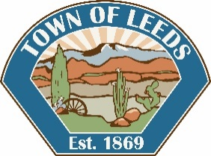

TOWN OF LEEDS

**NOTICE OF CANCELLATION**

**CANCELLED PUBLIC HEARING NOTICE**

Notice is hereby given that a Public Hearing at the

Planning Commission Meeting on

**Wednesday, July 6, 2022, at 7:00 p.m.**

At the Leeds Town Hall 218 North Main Street, Leeds, Utah.

**Subdivision Plat Amendment On Parcel L-73-A , Gay Egley**

Certificate of Posting

The undersigned Clerk/Recorder does hereby certify that the above notice was posted July 1, 2022.The public places being at Leeds Town Hall, Leeds Post Office, the Utah Public Meeting Notice website [http://pmn.utah.gov](http://pmn.utah.gov/), the Town of Leeds Website [www.leedstown.org](http://www.leedstown.org), also published in the Spectrum Newspaper.

_______________________________________

Aseneth Steed

Clerk/Recorder