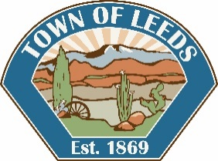

TOWN OF LEEDS

**Town Council Meeting**

**PUBLIC HEARING NOTICE**

Notice is hereby given that a Public Hearing will occur at the

Town Council Meeting on

**Wednesday, February 12, 2020 at 7:00 p.m.**

At the Leeds Town Hall 218 North Main Street, Leeds, Utah.

The Leeds Town Council will hold a public hearing on the above-mentioned date to consider the following proposed item:

Community Investment Board Approval for Grant

Copies of the proposed Grant Application will be available for review at the Leeds Town Hall during regular business hours (9:00 a.m. to 2:00 p.m. Monday – Thursday).

Interested persons are encouraged to attend the public hearing to be held in the Leeds Town Hall at 218 Main Street or present their views in writing to the Leeds Town Clerk/Recorder prior to the meeting.

Certificate of Posting

The undersigned Deputy Clerk/Recorder does hereby certify that the above notice was posted January 30, 2020.The public places being at Leeds Town Hall, Leeds Post Office, the Utah Public Meeting Notice website <http://pmn.utah.gov>, the Town of Leeds Website [www.leedstown.org](http://www.leedstown.org), also published in the Spectrum Newspaper.

Peggy Rosebush

Clerk/Recorder