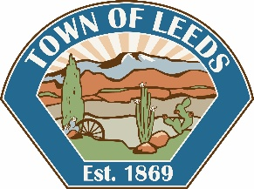

Town of Leeds

218 North Main Street

PO Box 460879

Leeds, UT 84746-0879

Phone: 435-879-2447

Fax: 435-879-6905

**PUBLIC NOTICE**

**TOWN OF LEEDS**

**CANVASS FOR THE 2019 MUNICIPAL ELECTION**

The Town Council of Leeds will hold the Election Canvass on:

**Wednesday, November 13, 2019, at 6:45 PM**

At Leeds Town Hall, 218 North Main Street

**Public is welcome to attend**

**AGENDA**

1. Call to Order / Roll Call
2. Pledge of Allegiance
3. Canvass of the 2019 Municipal Elections for the Town of Leeds
4. Adjournment

Peggy Rosebush

Clerk/Recorder